FORTIFY – INTERATIVE PASSWORD MANAGER

1. Project Overview

When I initially began brainstorming this project, I knew I didn't want to create a general password checker or manager. Security is bound to sound dry and ominous, so the question was: how do you make effective cybersecurity practices fun, memorable, and even interesting?

That line of thought drove the development of Fortify, a gamified web application in which good security practices are rewarded visually and interactively. Instead of the user simply being notified their password is “weak” or “strong,” the system turns their choices into the progression of a virtual fort. The better their defences in life (e.g., strong unusual password, 2FA), the better and more dramatic their virtual fort.

The app’s goals are:

To promote and reward good password practices.

To encourage users enabling two-factor authentication.

To teach lightweight, interactive security lessons.

To make the otherwise dull subject of “cyber hygiene” a game-like and inspiring one.

2. Core Concept

The employment of the figure of a fort was chosen due to the fact that it presents a picture of protection and strength easily discerned. The fort goes in four different steps of security:

Campfire Outpost — very exposed, no protection.

Wooden Hut — basic protection but still exposed.

Palisade Hold — tougher defenses, indicating foresight.

Castle Citadel — strong, lasting protection.

This graphical analogy makes the abstract notion of password security tangible. End-users literally can see their web defenses strengthen as they enhance their habits.

The fort upgrades are tied to XP, which users earn through:

Entering strong passwords

Assuring diversity in different locations

Adding 2FA to accounts

Completing short tests or quizzes

It not only allows for the measurement of progress but also provides a clear indication of achievement and growth.

I will share some visual examples of how the design is planned to look:  
  
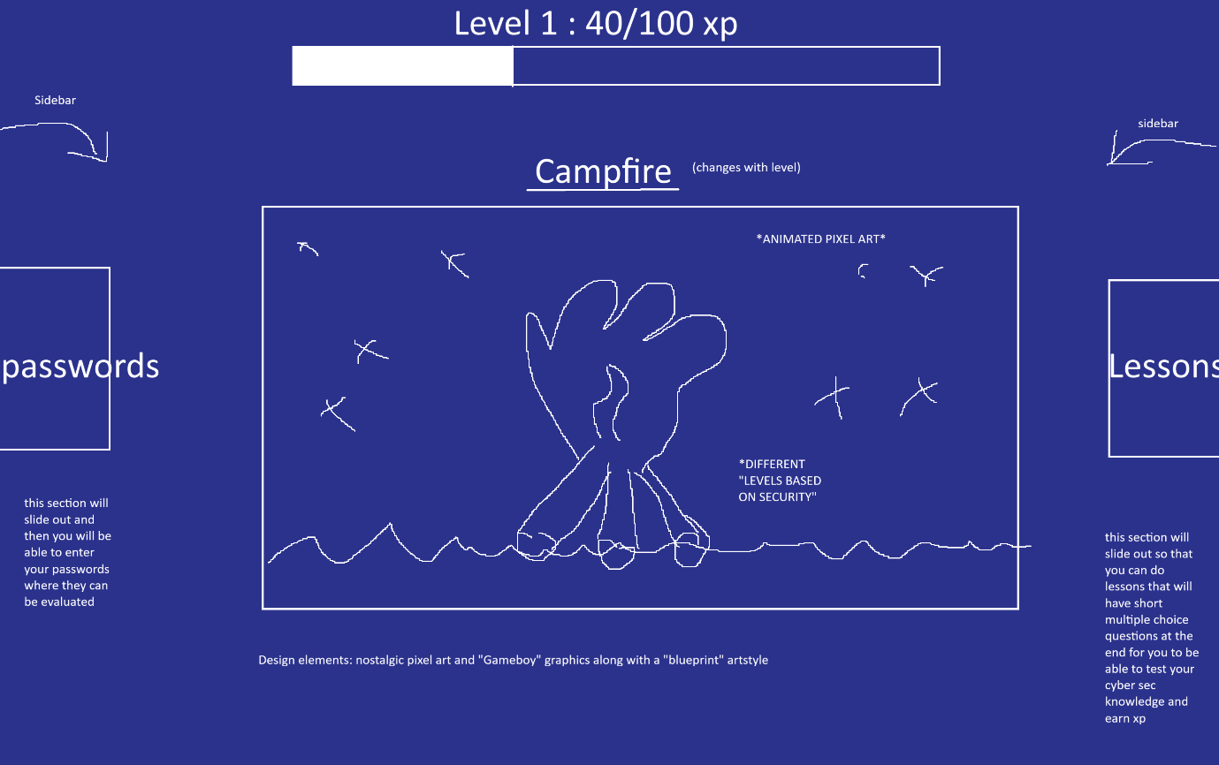

3. Gamification Mechanics

The first design choice was how to structure the XP system so it was rewarding without being overwhelming. Brainstorming brought them to the following set of rules:

Password Strength: Each password rewards the system proportionally by score (0–4) times 10. This enables the system to keep simple yet rewards good inputs.

Two-Factor Authentication: The implementation of 2FA for an account provides a flat increase of (+20 XP) because it is a significant security improvement.

Diversity: The user earns a reward of (+30 XP) for not utilizing the same type of powerful password for various accounts.

Lessons: A daily lesson provides a trustworthy low-hanging fruit (+50 XP) for motivation.

The level thresholds were kept low by design so players should at least have one or two level-ups during a short demo. The level-up animation — full of sparkles, flashes, and clear pixelated “LEVEL UP!” text — therefore best takes effect during a short play session.

4. Visual & Design Direction

The design decisions depended mainly on Fortify looking visually distinct and fun:

Theme: The “blueprint” theme (dark navy background and white/cyan outlines) was chosen so the interface would appear technical yet accessible, and even an amusing schematic for building defenses.

Font: A retro pixel font (Press Start 2P, VT323) emphasizes the game-like nature.

Art Style: The pixel art fort assets scaled up by sharp pixel rendering were selected for their retro appeal and readability.

Layout:

The innermost column is the main stage for the XP bar and the fort display.

Left drawer: A “Vault Panel” in which users mimic adding password entries and 2FA toggling.

Right drawer: A “Lessons Panel” offering quizzes or challenges.

Top-right: An account indicator for a personal app's experience.

Onboarding Modal: A welcoming popup to introduce new users and explain the Fortify concept before getting started.

Every visual decision reinforces the fact that Fortify is not a utility but an experience.

5. Planned Features

It assisted in dividing the features and determining what was possible in a short build window and what was reserved for later:

Fort Evolution: The centerpiece — 4 stages of a fort that develop along the user’s security practices.

XP & Level System: Animations and smooth progress bars without thresholds and clear feedback.

Vault Panel: Schematic password manager records, updating experience points instantly.

Panel of Lessons: Bonus points for daily quizzes or micro-games.

Account & Onboarding: A lightweight demo sign-in indicator and a motivating first-load popup.

6. Development Scope and Priorities

Given hackathon constraints, I split features into MVP and stretch goals.

MVP (demo must-have):

XP system

Fort sprite progression

Vault panel with fictional records

Lessons panel without quiz

Level-up animation

First-time onboarding modal

Stretch Goals (time allowing):

More lesson content

Leaderboards

Persistent user state

Upgradeable animated forts instead of in-place sprite substitutions

This prioritization allows a small build to feel complete and demo-ready while allowing for potential expansion in the future.

7. Value Proposition

The value proposition of Fortify lies in redescribing cybersecurity:

Educational: It teaches best practices like strong one-time use passwords and 2FA in a way that sticks.

Motivating: Gamification motivates by providing rewards, levels, and visual progression.

Memorable: The pixel blueprint aesthetic is recognizable and attention-grabbing.

Scalable: It can be converted into a lightweight gamified password manager or an expanded digital security learning platform.

In a nutshell, Fortify turns something easily taken for granted — password hygiene — into a fun, uplifting experience.